**LAB ASSIGNMENT-9.3**

**Task Description#1 Basic Docstring Generation**

* Write python function to return sum of even and odd numbers in the given list.
* Incorporate manual **docstring** in code with Google Style
* Use an AI-assisted tool (e.g., Copilot, Cursor AI) to generate a docstring describing the function.
* Compare the AI-generated docstring with your manually written one.

**Expected Outcome#1:** Students understand how AI can produce function-level documentation

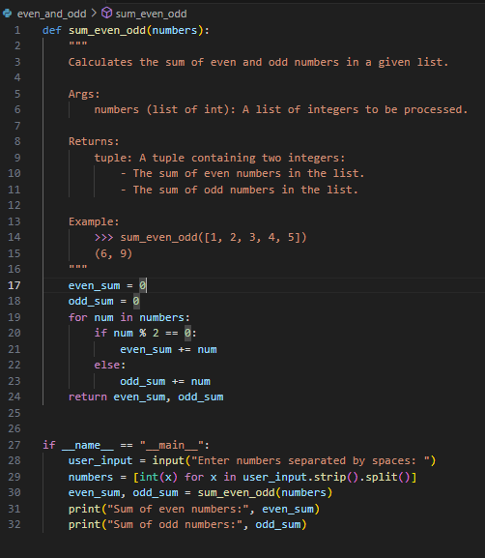

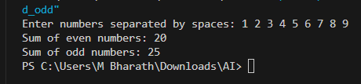

**Manual Docstring:**

"""

Calculates the sum of even and odd numbers in the provided input list.

input:

numbers (list of int): A list of integers.

Returns:

tuple: A tuple containing :

- The sum of even numbers.

- The sum of odd numbers.

"""

**AI Generated Docstring:**

"""

Calculates the sum of even and odd numbers in a given list.

Args:

numbers (list of int): A list of integers to be processed.

Returns:

tuple: A tuple containing two integers:

- The sum of even numbers in the list.

- The sum of odd numbers in the list.

Example:

>>> sum_even_odd([1, 2, 3, 4, 5])

(6, 9)

"""

**Task Description#2 Automatic Inline Comments**

* Write python program for **sru_student** class with attributes like name, roll no., hostel_status and **fee_update** method and **display_details** method.
* Write comments manually for each line/code block
* Ask an AI tool to add inline comments explaining each line/step.
* Compare the AI-generated comments with your manually written one.

**Expected Output#2:** Students critically analyze AI-generated code comments.

**Manual Comments:**

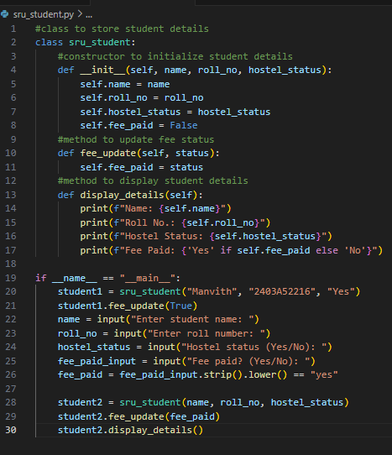

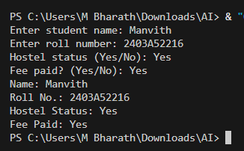

AI Generated Comments:

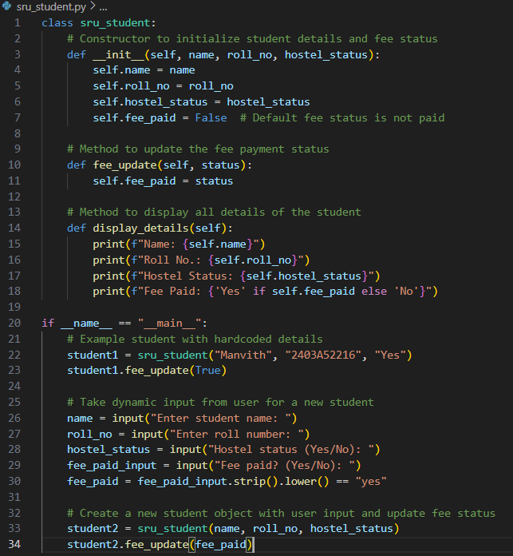

**Task Description#3**

* Write a Python script with 3–4 functions (e.g., calculator: add, subtract, multiply, divide).
* Incorporate manual **docstring** in code with NumPy Style
* Use AI assistance to generate a module-level docstring + individual function docstrings.
* Compare the AI-generated docstring with your manually written one.

**Expected Output#3:** Students learn structured documentation for multi-function scripts

